# Integration test

In integration testing all the individual’s units test are completed as a group together. The first reason of this level of test is uncovering the main errors within the interaction among the units of integrated. For helping with integration testing there are need to use test drivers and test stubs.

|  |  |  |  |  |  |
| --- | --- | --- | --- | --- | --- |
| **Id** | **Title** | **Pre-Condition** | **Test Step** | **Actual Result** | **Excepted Result** |
| **2.1** | Add schedule of program | Admin must be logged in the site | Must be fill-up field | Admin can add schedule of program | Except |

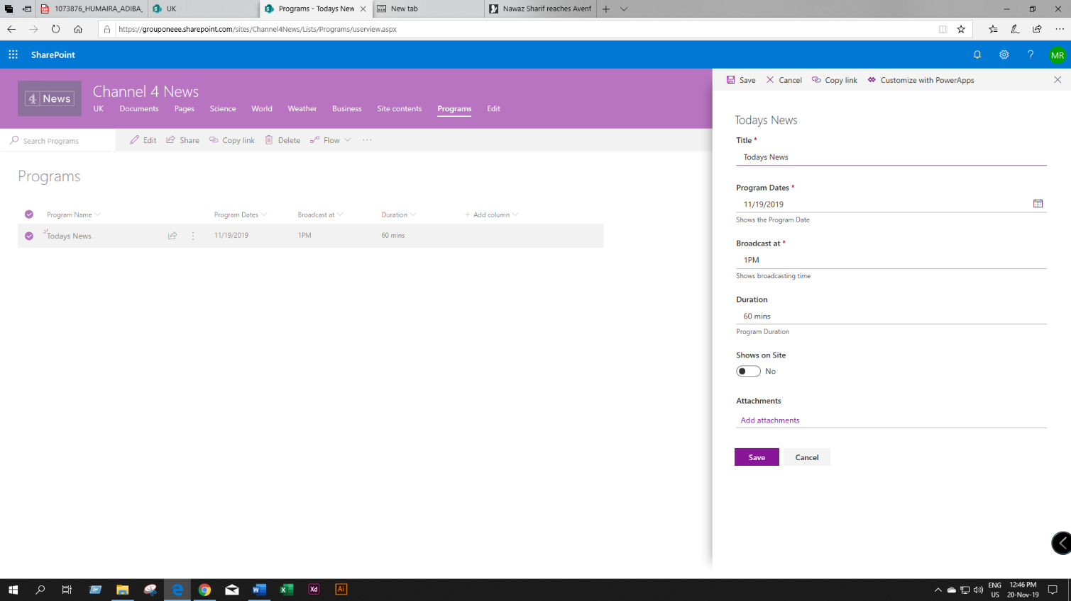

Figure 3: Add schedule of program